Summary of Measures to be used in the Vulnerability component of GAINTM.

The GAIN will follow a consistent structure based on the best of published thinking on the topic, the IPCC Review process, and guidance received from the Council of Scientists and the Advisory Board.

The basic structure will focus on an initial set of ‘sectors’ made up of Water, Food, Health with the initial inclusion of an infrastructure section that includes Coastal, Transport and Energy. Within each of the sectors vulnerability will be represented by three components describing Exposure, Sensitivity and the Capacity to cope/adapt. The Vulnerability axis of GAINTM should represent the vulnerability and adaptive capacity that is largely in the domain of action by communities, Civil Society Organizations and/or national governments. Adaptive capacities that may realistically be influenced by the private sector should usually be in the Readiness Axis.

Based on the May 2011 Meetings, the following criteria were used in selecting the measures for inclusion in the GAINTM:

1. Meet user needs and are transparent and conceptually clear.
2. Consistent with current knowledge / best practice.
3. Composed of a select set of variables with the selection based on a logical structure; e.g. selected sectors each treated by Exposure – Sensitivity – Capacity as described above.
4. Uses data that are accessible, quality checked, and comprehensive in national coverage.
5. The Sensitivity and Capacity measures should be actionable; i.e. they can be influenced by actions and leading to measurable changes within a few years.
6. The Sensitivity and Capacity measures should have time series of data available wherever possible so that national progress over the past decade or so can be tracked.
7. Potentially scalable from national to regional and local.
8. They should not directly incorporate broad socio-economic measures, such as GDP/capita, HDI etc, but instead focus on variables that are directly representative of the sector and the components of vulnerability.
9. Selection of measures should be guided by existing relevant indices and the GAINTM outcome compared with those indices.

The working model is as follows…

For each of the sectors (water, food, health) two streams of measures are incorporated; one describing essentially quantitative measures (amount of water, how much is used, how many have access) and the other where possible quality measures (exposure to poor quality water, impacts of poor water on people, access to quality management measures). The selection will always be a subjective exercise, but some greater objectivity is introduced by following the above guidelines and the systematic structure. Numerous variables (c. 20 different measures for water alone) have been considered and tested against the guidelines in making the selection.

The Table below briefly describes the selection for the draft version of GAIN 1.0. They are subject to revision based on further analysis and advice from the Council of Scientists, the Advisory Board and wider public consultation.

|  |  |  |  |  |
| --- | --- | --- | --- | --- |
| Sector |  | Exposure | Sensitivity | Capacity |
| Water | Quant | **Projected change in precipitation (%).** Gross measure of threat to water resource – change in run-off would be better but not available currently in a comprehensive and authoritative data set. | **% internal and external freshwater water extracted for all uses.** An indication of how much of the nationally controllable resource is already being used. | **% population with access to improved water supply.** High % indicates capacity to deliver water to the population and hence lower vulnerability. |
|  | Qual | **Projected change in temperature**. Water quality issues rise in warmer conditions as disease growth & spread increases; less water for sanitation etc. {Also brings temperature into the axis} | **Mortality among under 5 yr-olds due to water borne diseases**. Measure of current extent of impacts due to poor water quality (and to a lesser extent quantity). | **% population with access to improved sanitation**. As above. |
| Food | Quant | **Projected change in agricultural (cereal) yield** (based on Wheeler 2011). Cereal yield is often treated as the most effective indicator of the effects of climate on food supply. This measure is a compilation of several estimates of the effect of projected climate change on cereal yield. | **% of population dependent on rural livelihoods**. These people are the most sensitive to impacts either through direct food production or loss of livelihood. | **“Modernization” of agriculture.** A combined measure of fertilizer use per ha of arable land, percentage or arable land irrigated and the mechanization (number of tractors per ha) of agriculture. Not all of these measure are relevant to (or reported by) all countries so the average of the two best (least vulnerable) measures is used. |
|  | Qual | **Coefficient of Variation in cereal crop yields.** This is a measure of the ratio of the standard deviation to the mean national cereal yield over the past 20 years (corrected for technological yield increases) and reflects the exposure of national crop yields to the climate and other national effects. | **Cereal Import Dependency.** This is the ratio of imported to total consumption of cereals and is an indicator of the sensitivity of food supply to international trends. | **% under 5 year-olds with “wasting”.** This measures low weight to height ratios and is considered the best measure of persistent malnutrition. High malnutrition among young children is a strong indicator of low capacity to deliver food. |
| Health | Quant | **Estimated impact of current CC on DALYs**. These are based on work by WHO and published in Ebi 200x. | **Doctor & Nurses per cap**. A measure on-the-ground delivery of health services. | **Longevity**. Greater longevity implies better capacity for health support either through medical services or through community practices. |
|  | Qual | **% of total mortality due to communicable (infectious) diseases.** An indication of the exposure of the population to factors likely to worsen under climate change. | **% of health expenditure derived from external resources.** A indicator of the sensitivity of the local health systems to any form of shock. | **Maternal Mortality.** Lifetime risk of female mortalitydue to maternity related factors. High mortality indicates poor capacity to deliver health care to a vulnerable group. |
| Infrastructure sectors | | | For the 3 infrastructure sectors only one set of exposure, sensitivity and capacity measures is included | |
| Coastal | Quant | **% land below 5 m.** This is the zone that is subject to threats from sea level rise and storms. | **% Population in the zone below 5m.** Sensitivity of both people and to a large extent infrastructure. | $GDP/Area??? As in GAIN 0.5  No measure is included at this stage. All countries receive a default score of 0.5 |
| Energy | Quant | **% population with access to reliable energy**. People without access to electricity will remain vulnerable to impacts on the energy sector, either through impacts on traditional energy sources or through delays in achieving eventual access. | **% energy derived from either imports or hydro-power**. As both could be vulnerable under climate change. {Should the exposure & sensitivity measures be swapped? There is only a single estimate for energy access and a time series for the source of energy.} | **GDP (PPP 2005 $) produced per unit of energy consumed**. Measure of the capacity to use energy effectively. |
| Transport | Quant | **Number of floods reported in the CRED data-base** over the period1992 to 2007 divided by total land area. Floods represent the major threat to transport infrastructure in many part of the world. | **% of roads that are paved**. Paved roads are usually much less sensitive to climate impacts than unpaved. | **Currently: Vehicles per capita.** Will explore the **Ratio of road density to population density** where a low value implies low capacity to deliver. |
|  |  |  |  |  |

The following section is a technical annex describing each of the measures in detail.

Discussion of the water measures

|  |  |  |  |  |
| --- | --- | --- | --- | --- |
| Sector |  | Exposure | Sensitivity | Capacity |
| Water  See Box 1 for the relationship between the GAIN and the Water Povert Index (WPI) | Quant  **  ** | **Projected change in precipitation (%).** **[PPT% ⬆][1]** Gross measure of threat to water. This is the commonly used indicator in both the scientific and response communities. However it is not a very effective measure as it does not take increased evaporative demand into account nor changes in the intensity and seasonality of the rainfall. It might eventually be replaced by a more integrating measure such as run-off or even precipitation minus evapotranspiration. The use of a single measure for an entire country is not very valid, especially for large countries where there are large gradients across the country.  **Issues :** An increase in PPT% is taken to indicate reduced vulnerability. However, this might be misleading for dry countries where a large % increase does not imply a large absolute increase in rainfall or in rainfall effectiveness. The increased rain may come in flooding events. Similarly increased PPT% for already wet countries probably provides little useful additional water and may add to flood loads. There appears to be no objective way to correct for these problems but a subjective correction is suggested below.  It can also be argued that PPT% is is a reasonable approximation – for countries with low current precipitation an increase will be disruptive especially if flood frequency increases; for high precipitation countries additional precipitation is also disruptive. There is a range in the middle where additional rainfall might be beneficial but it is hard to adjust for this. Note however, that this is partially taken up in the AG WHEELER.  **Scaling :** The base value is taken to be no change and the index is scaled so that the most negative countries score -1 and the most positive +0.5. This partially accounts for the issues discussed in the previous paragraph.  **Cross Correlation :** Very low  **Reporting & Time Series :** All countries and a single measure only as it is a projection.  **Actionable :** Only via mitigation of GHG emissions.  **Private Sector Messages** **:** None {This is a mitigation issue. Obviously the private sector can play a role there but that is not the purpose of this index.}  **Public Sector Messages :** Actionable through mitigation.  **Alternate or related measures : See comment on run-off above.**  **Summary :** Acceptable for now, but seek eventually to update with a better measure of water impacts. | **% internal water extracted for all uses. [IWE% ⬆]** An indication of how much of the nationally available water resource (originating internally or externally such as from inflowing rivers) is already being used. In the Index a high % extraction is taken as an indicator of vulnerability.  **Issues:** Some countries (especially arid) use well over 100% of their internal water as it is either supplemented by desalination for example. These are capped to 100%.  **Scaling :** The base value is taken as 0% (=0) and 100% (=1).  **Cross Correlation :** Capped variable has low correlation with both GDP/Cap or HDI (r2 < 5%) with or without cap. It is in fact little correlated with most other measures.  **Reporting & Time Series :** Data is reported to FAO at 5 yearly intervals. About 40% compliance since 1990 with enough to detect trends in about half the countries.  **Actionable :** Water use includes domestic, industrial and agricultural of which agricultural water use is the dominant water use in most countries. Thus, this is more a measure of the threat to agriculture than the threat to domestic or industrial use.  **Private Sector messages :** This is a comprehensive measure whose value is determined by many different actions and policies. However, many of these actions are appropriate for private sector engagement ranging from water efficiency measures and recycling to desalination.  **Public Sector Messages :** Similar to those described above. Many opportunities for PPPs.  **Alternate or related measures** : Could exclude external water, but this leads to the anomaly of countries such as Zambia, with major river systems flowing through them, show as very water scare. Zambia uses only 2% of its total available water, but this greatly exceeds the amount of internally generated water. Could also include the volume of dam storage to give some idea of buffering capacity.  **Summary :** Solid measure by most criteria and one used in other indices. The main issue is whether it truly does reflect vulnerability. | **% population with access to improved water supply.** [PIW% **⬇**]High % indicates capacity to deliver water to the population and hence lower vulnerability.  **Issues :** Commonly used indicator. However, it saturates very quickly with most countries with a GDP/cap of >$5000 having close to 100% coverage  **Scaling :** Scale 0% as vulnerability of 1 and 100% as 0 vulnerability.  **Cross Correlation :** Highly correlated with HDI (r2 = 65%) and with GDP/cap (r2 = 25% and r2 = 50% with Ln(GDP/cap)). It is also correlated with PIS%.  **Reporting & Time series :**  **Actionable :** Directly actionable although many countries have already reached the highest score.  **Private Sector messages :** An activity with many opportunities for private sector engagement, especially through PPPs.  **Public Sector Messages :**    **Alternate or related measures :**  **Summary :** Good indicator and commonly used in other indicators. |
|  | Qual | **Projected change in temperature** (TMP% **⬆**). Water quality issues rise in warmer conditions causing disease growth & spread; less water for sanitation etc.  **Issues :** This brings the most commonly used climate change indicator into the index. The use of a single measure for an entire country is not very valid, especially for large countries where there are large gradients across the country.  **Scaling :** The base value is taken to be no change and the index is scaled so that the most positive temperature increases (5.5C) score +1 and the lowest (1.5C) score 0.  **Cross Correlation :** Very low  **Reporting & Time Series :** All countries and a single measure.  **Actionable :** Only via mitigation of GHG emissions.  **Private Sector Messages** **:** None {This is a mitigation issue. Obviously the private sector can play a role there but that is not the purpose of this index.}  **Public Sector Messages :** Actionable through mitigation.  **Alternate or related measures :** No obvious alternatives.  **Summary :** A core measure of projected climate change and used as the basis of many projections, indicators etc. | **Existing incidence of water borne diseases (WBD ⬆)**. Measured as “Water, sanitation & hygiene deaths per 100'000 children<5 yr” to capture the effects on the most sensitive portion of the population.  **Issues :** There are similar data for all people affected but we have chosen to focus on children as they bear the bulk of the burden. There is obviously an overlap with health measures, but this reflects the strong links between vulnerability arising within the water and health sectors.  **Scaling :** The base values are taken to be no incidence (scoring 0) and 1500 incidences per 100,000 children per year, which will result in a small group of countries scoring close to 1.  **Cross Correlation :** Correlates with r2 of 50% to 60% with PIW% and PIS%. But only 35% with ln(GDP/cap).  **Reporting & Time Series :**  **Actionable :** Directly actionable with many countries having room for improvement. Overall improvement in PIW% and PIS% would improve WBD but there also a range of health related actions available.  **Private Sector Messages** **:** Opportunities for the private sector through a variety of clean water and health interventions. Probably a role for local SMEs in providing improved services to emerging cash economy farmers and middle class.  **Public Sector Messages :**  **Alternate or related measures** : A similar measure is available for the whole population. However, children under 5 account for the largest portion of deaths.  **Summary :** | **% population with access to improved sanitation [PIS% ⬇]**. High % indicates capacity to deliver sanitation and quality water to the population and hence lower vulnerability.  **Issues :** Commonly used indicator. However, it saturates quickly, although slightly slower than PIW%, with most countries with a GDP/cap of >$12000 having close to 100% coverage  **Scaling :** Scale 0% as vulnerability of 1 and 100% as 0 vulnerability.  **Cross Correlation :** Highly correlated with HDI (r2 = 75%) and with GDP/cap (r2 = 35% and r2 = 50% with Ln(GDP/cap)). It is also correlated with PIS% (r2 = 60%) but there is still significant scatter among countries with low values of either variable.  **Reporting & Time Series :**  **Actionable :** Directly actionable although many countries have already reached the highest score.  **Private Sector Messages** **:** An activity with opportunities for private sector engagement, especially through PPPs. More difficult to achieve payments for service than for actions relating to PIW%.  **Public Sector Messages :**  **Alternate or related measures :**  **Summary :** Good indicator despite its high correlation with PIW%. There are differences between countries on the low end of both measures. |

**Results for the Water Sector.** Full data are available for 147 UN member countries (out of 192) with many Small Island States having missing data. This can probably be improved with additional searches for missing data. The time series analyses are not yet complete.

|  |  |  |  |  |  |
| --- | --- | --- | --- | --- | --- |
| **Most vulnerable** | | **Median Set** | | **Least Vulnerable** | |
| Niger | 0.35 | China | 0.71 | Argentina | 0.85 |
| Mauritania | 0.37 | Uganda | 0.71 | Costa Rica | 0.85 |
| Afghanistan | 0.40 | Cameroon | 0.71 | Ecuador | 0.86 |
| Iraq | 0.45 | United Arab Emirates | 0.72 | United Kingdom | 0.86 |
| Somalia | 0.46 | Malta | 0.72 | Iceland | 0.87 |
| Azerbaijan | 0.47 | South Africa | 0.72 | Chile | 0.87 |
| Sierra Leone | 0.52 | Sao Tome and Principe | 0.73 | Malaysia | 0.88 |
| Sudan | 0.53 | Barbados | 0.73 | Brunei Darussalam | 0.90 |
| Turkmenistan | 0.54 | Djibouti | 0.73 | Uruguay | 0.92 |
| Madagascar | 0.55 | Bulgaria | 0.73 | New Zealand | 0.92 |

A number of pairwise comparisons were done during the selection process and this will be a feature of the final software and web presentation of GAIN.

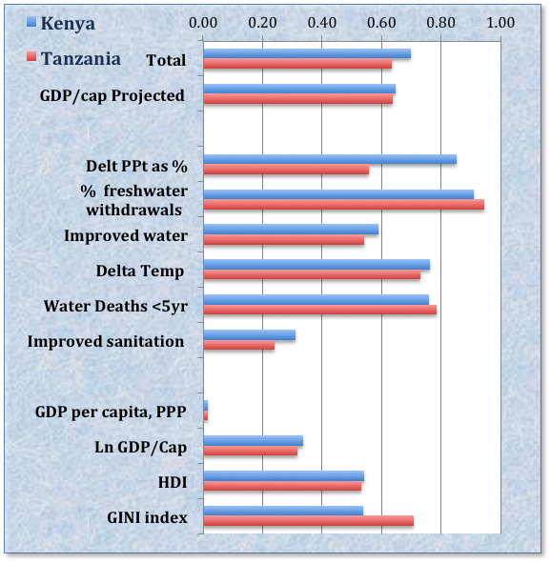

Many poorer countries argue that many indices simply double penalize them by either directly including GDP/capita in the formulation of the index or by including it indirectly through highly correlated variables. In some circumstances this works against the poorest by categorizing them as too poor/weak etc for effective action and in others against middle income countries by amplifying the effects of increasing GDP/cap and directing support away from them to early in their development process. It is inevitable that there will be a correlation between high vulnerability and low GDP/cap and this is the case for the water sector in GAIN. However, it is relative low (r2 = 36% with log[GDP/cap]) compared with either the WPI (55%) or the HDI (88%), so it does appear to be gathering components of sector relevant information different from these other indices.

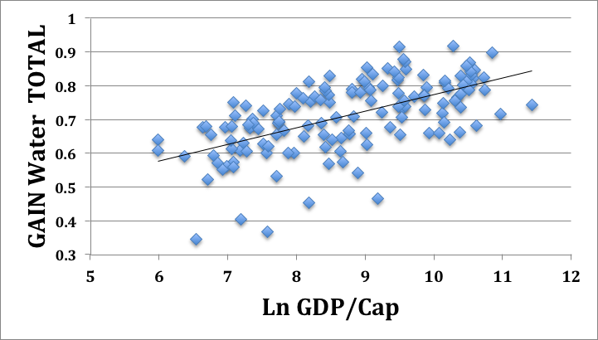

|  |  |  |  |  |  |
| --- | --- | --- | --- | --- | --- |
| Vulnerability | | | | | |
| Least | | Middle | | Most | |
| Denmark | 113 | Turkmenistan | 290 | Rwanda | 482 |
| Norway | 132 | Moldova Rep. | 293 | Burkina Faso | 484 |
| United Kingdom | 139 | Albania | 293 | Samoa | 485 |
| Ireland | 148 | Belize | 295 | Guinea-Bissau | 488 |
| Switzerland | 149 | Azerbaijan | 296 | Yemen | 488 |
| Germany | 149 | Costa Rica | 296 | Liberia | 491 |
| France | 150 | Kuwait | 296 | Mauritania | 493 |
| Sweden | 153 | Syrian Arab Rep. | 297 | Angola | 494 |
| Finland | 154 | Cuba | 297 | Mali | 496 |
| New Zealand | 158 | Sri Lanka | 300 | Tanzania | 496 |
| Czech Republic | 158 | Saudi Arabia | 301 | Vanuatu | 503 |
| Austria | 167 | Indonesia | 302 | Sierra Leone | 504 |
| Luxembourg | 171 | Antigua & Barbuda | 302 | Central African Rep. | 517 |
| Poland | 174 | Paraguay | 306 | Ethiopia | 520 |
| Italy | 188 | Peru | 309 | Niger | 520 |
| Qatar | 188 | Tunisia | 310 | Burundi | 524 |
| Uruguay | 191 | Algeria | 311 | Zambia | 530 |
| United States | 192 | Kyrgyzstan | 311 | Mozambique | 538 |
| Croatia | 193 | Philippines | 313 | Afghanistan | 544 |
| Spain | 198 | Bhutan | 314 | Micronesia | 567 |

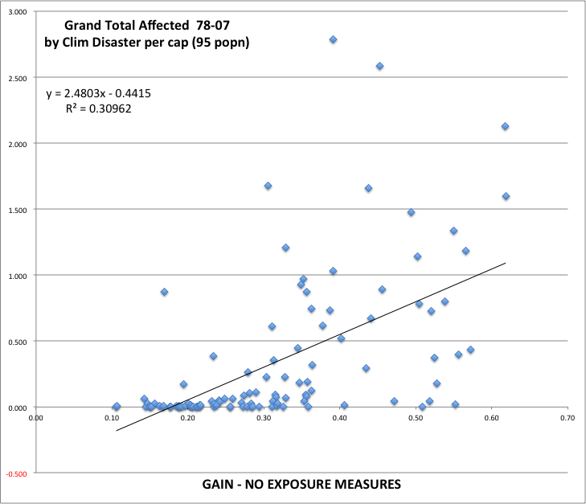

Although there is a lot of scatter the GAIN is significantly correlated with the risk that people currently face (1978 to 2007 in CRED data-base) of being affected by a climate related disaster (R2 = 0.31). In this analysis the Exposure measures have been omitted as they relate to the future not the present. Also, the only time the CRED disaster information is used in constructing GAIN is as an exposure measure for transport, so there is no information from CRED built into this version of the GAIN.

This result could also be interpreted as suggesting that for every 0.1 decrease in the GAIN vulnerability score the percentage of people within a country being affected by a climate related disaster per decade falls by about 8 to 10%.

The correlation of ln(GDP/cap) with the risk of being affected is only r2 = 0.15, so the GAIN is a better predictor than GDP/cap. Or, expressed in another way to get the equivalent effect on the probability of being affected as would result from reducing a country’s GAIN by 0.1, GDP/cap would have to increase by about 4 fold. This would take about 18 years of GDP growth at 8% per annum or 35 years at 4%.

**Box 1. GAIN and the Water Poverty Index (WPI)**

|  |  |
| --- | --- |
| **WPI Component Data Used** | **GAIN** |
| **Resources** |  |
| 1. • internal Freshwater Flows | Indirectly included in the measure of water withdrawal as a percent of internal + external inflows |
| 1. • external Inflows |
| 1. • population | Not a measure of water resources |
|  |  |
| **Access** |  |
| 1. • % population with access to clean water | Included |
| 1. • % population with access to sanitation | Included |
| 1. • % population with access to irrigation adjusted by per capita water resources | Not included but considered for the Agriculture / Food measures. Data is poorly reported. |
|  |  |
| **Capacity** |  |
| 1. • ppp per capita income | Not a measure of water resources |
| 1. • under-five mortality rates | Similar, but more specific, measure used – viz “Under 5 year-old Mortality due to water borne diseases”. The two measure are highly correlated, but the GAIN measure is more directly water related. |
| 1. • education enrolment rates | Not a measure of water resources |
| 1. • Gini coefficients of income distribution | Not a measure of water resources |
|  |  |
| **Use** |  |
| 1. • domestic water use in litres per day | Considered, but the more important measure is captured in % population with access to clean water |
| 1. • share of water use by industry and agriculture adjusted by the sector’s share of GDP | Considered under agriculture, but included indirectly in the GAIN measure of water withdrawal as this is usually dominated by agriculture |
|  |  |
| **Environment** | Not considered at this point in the GAIN |
| 1. • water quality |  |
| 1. • water stress (pollution) |  |
| 1. • environmental regulation and management |  |
| 1. • informational capacity |  |
| 1. • biodiversity based on threatened species |  |

The WPI does not deal with climate change or directly with climate impacts. It seeks to cover a wider domain than the water component of the GAIN with 17 measures compared to 6 for GAIN and the WPI includes environment and water pollution measures that are not considered in this component of GAIN. The WPI also includes socio-economic measures (e.g. GDP per capita, GNI etc) that are not considered for explicit inclusion in GAIN.

Nevertheless, the two indicators are highly correlated (r2 = 45%), but with no clear systematic differences. Some of the difference may arise from changes in reporting (the WPI data were gathered almost a decade ago) and from the inclusion of the climate change projections for temperature and precipitation in the GAIN,

which reflects the different purposes of the two indices. This is borne out by removing the climate projection component from the GAIN index and the correlation with the WPI rises to r2 = 60%.

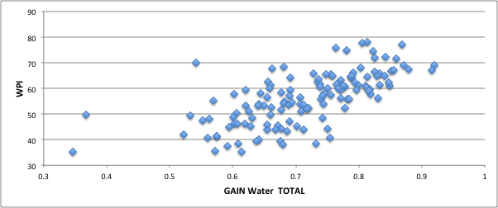

1. **** values for the measure indicate greater vulnerability; **** indicates that low values indicate greater vulnerability. Each measure is rescaled to a range from 0 to 1 with 1 indicating high vulnerability before being incorporated in the GAIN Vulnerability Index.